Documentasi External

* composer require laravel/ui:^2.4

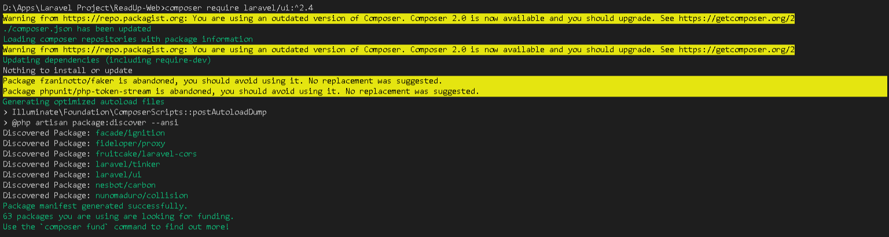

* php artisan ui bootstrap

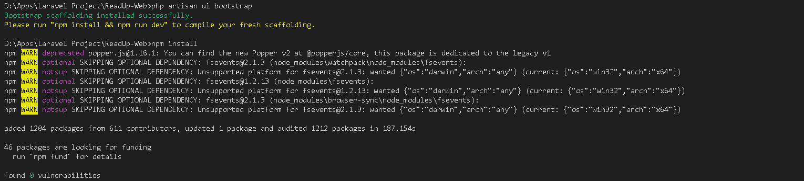

* npm install

